English Vocabulary – Birth / Marriage / Death
 | 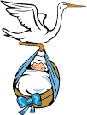 |  | 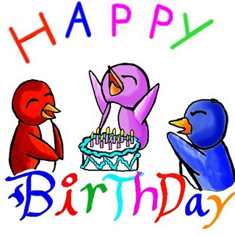
to get pregnant  to be pregnant | birth, to be born  to give birth | newborn | birthday
 | 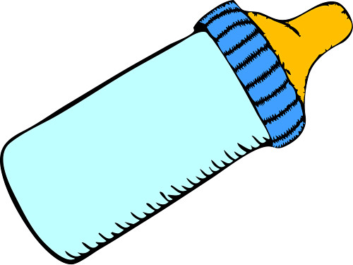 | 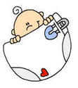 | 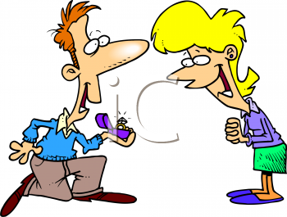
breast /  to breast-feed | bottle /  to bottle-feed | nappy (UK)  diaper (USA) | to propose  fiancé(M)/fiancée(F)
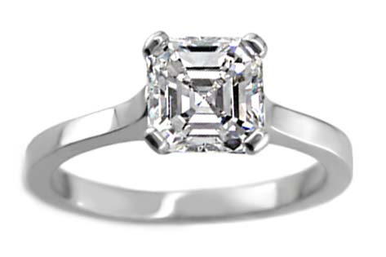 |  |   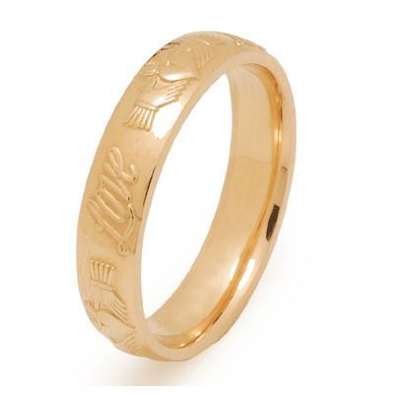   | 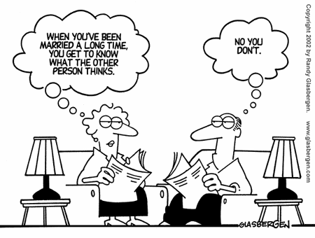
to get/be engaged  engagement ring | wedding (noun)  to marry  to get married | bride/groom  best man/bridesmaid  wedding ring | married (adj)  marriage (noun)
 |  | 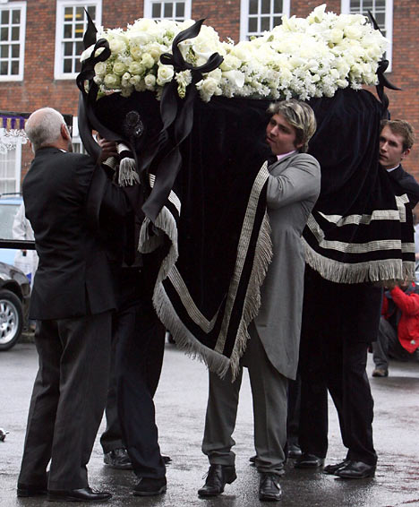 | 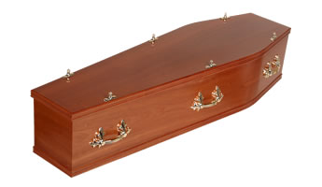
to die  to pass away | dead (adj)  death (noun) | undertaker | coffin / to bury  burial / cremation
 |  | 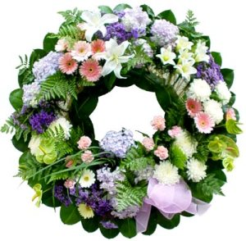 | 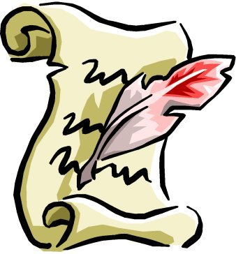
funeral / wake * | grave / plot | wreath | will
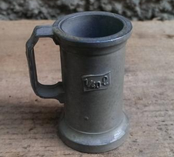
* Origin of the word “wake”
In the 16th century, lead cups were used to drink ale or whiskey. The combination of lead and alcohol would sometimes knock you out for a day or two. Someone walking along the road would assume that they were dead and prepare them for burial. However, they were put on the kitchen table for two days and the family would wait to see if the person would wake.

(No século 16, os copos de chumbo eram usados para beber cerveja ou uísque. A combinação de chumbo e álcool às vezes deixava uma pessoa inconsciente por um ou dois dias. Alguém caminhando pela estrada presumiria que a pessoa estava morto e a prepararia para o enterro. Porém, ela era colocada na mesa da cozinha por dois dias e a família esperava para ver se a pessoa acordava.)


Celebrations:
birthday party
stag party / hen party
engagement party / bridal shower
wedding party
baby shower
funeral
wake

Marriage vows:
I, _____, take you, _____, for my lawful wife/husband, to have and to hold from this day forward, for better or for worse, for richer or for poorer, in joy and in sorrow, in sickness and in health, to love and to cherish, as long as we both shall live.

Wedding Anniversaries (Bodas de Casamento)

 | UK/USA | Brazil
1st | Paper
2nd | Cotton
3rd | Leather | Trigo
4th | Flowers
5th | Wood
6th | Iron | Perfume
7th | Wool
8th | Bronze | Papoula
9th | Pottery
10th | Tin
11th | Steel
12th | Silk
13th | Lace
14th | Ivory
15th | Crystal
20th | China
25th | Silver
30th | Pearl
35th | Coral
40th | Ruby | Esmeralda
45th | Sapphire | Platina
50th | Gold
55th | Emerald | Ametista
60th | Diamond

